Guided Capstone Project Report

Based on the model, the ticket price for Big Mountain Resort has potential to be increased. The current ticket price $81 is much lower than the predicted price of $95.87.

The model was built based on all resorts in the US that can be considered part of the same market share. By looking at the most important 8 features that affect the ticket price, it shows that Big Mountain stands out amongst all resorts. It also provides the business team an idea of what features worth future improvements. These features are: vertical drop, area covered by snow makers, total number of chairs, number of fast quads, total number of runs, longest run length, number of trams, and skiable terrain area.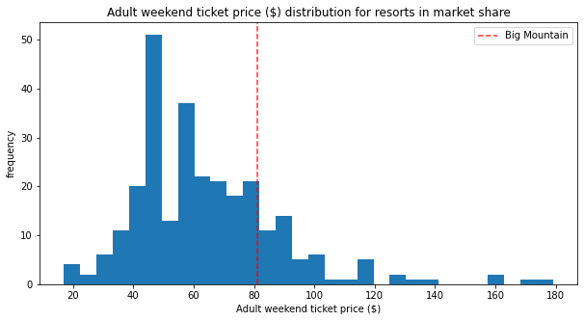

However, the only known operating cost is the cost for installing an additional chair lift, which is $1,540,000 per season. If the business team wants to add any other features to support a higher ticket price, it will also bring up more cost to cut off the revenue. If we believe that other resorts have reasonable pricing strategies, we can test with a higher ticket price by adding some new features like one of the modeled scenarios. Big Mountain can add a run, increase the vertical drop by 150 feet and install an additional chair lift. This scenario would result in an increase to the predicted ticket price by $1.99. In the meantime, business can still close down some least used runs. Based on the model, I would suggest close either 4-5 runs or 7-8 runs since they don’t affect the ticket price that much. The exact number depends on how much it could save by closing a run.

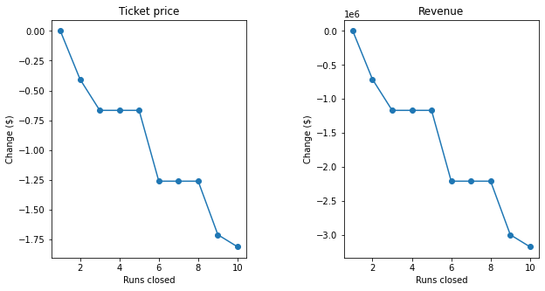

The model tells us that even if we close 10 least used runs, it will only lower the predicted price by $1.81. The new predicted price $94.06 is still much higher than the current ticket price. If we add into consideration of the mean absolute error $10.39, the lower bound is $83.67, which is still above $81.

In conclusion, the model shows that the current arrangement of facilities of Big Mountain could support higher ticket prices. If the team wants to reduce the operating cost or improve existing facilities, we can focus more on vertical drop, number of runs, number of fastQuads and snow making area.